Why do tasks seem to run concurrently when there aren’t enough cores to allow for concurrent execution? The figure below shows the results of running 10,50,128 tasks on one core on comet. The tasks were coded(on EnTK) to run concurrently. Each task “sleeps” for 100 seconds.
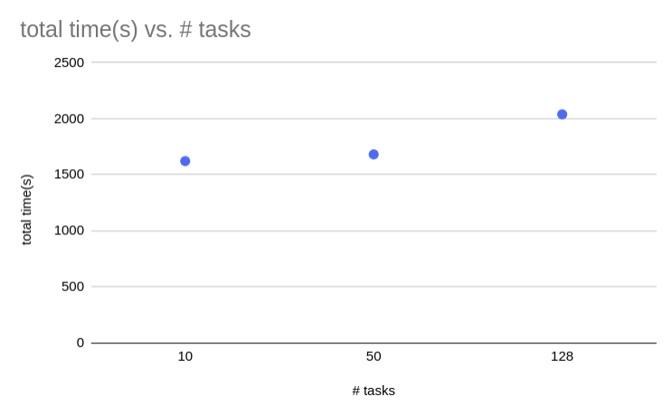
My expectation: with one core, I should only have 2 threads. Thus, I should only be able to run 2 tasks concurrently. The table below shows the results I expected and the results from the experiment.

The problem: the experimental results suggest that more than 2 tasks at a time were able to run concurrently.

let TTX(i) denote the total time of execution for i tasks
 | Experimental result | Expected result
TTX(50) / TTX(10) | 1.03 | 5
TTX(128) / TTX(10) | 1.25 | 12.8

